Course Specialist Test 3 Year 12

Student name: ________________ Teacher name: ________________

Task type: Response

Time allowed for this task: ____40_______ mins

Number of questions: _____7______

Materials required: Calculator with CAS capability (to be provided by the student)

Standard items: Pens (blue/black preferred), pencils (including coloured), sharpener, correction fluid/tape, eraser, ruler, highlighters

Special items: Drawing instruments, templates, notes on one unfolded sheet of
A4 paper, and up to three calculators approved for use in the WACE examinations

Marks available: _44_____ marks

Task weighting: _10___%

Formula sheet provided: Yes

Note: All part questions worth more than 2 marks require working to obtain full marks.

Q1 (6 marks) (3.3.9-3.3.10)
- Solve the following system of linear equations. (3 marks)

- Determine all possible values of for the three scenarios below. (3 marks)

- No solutions
- One solution
- Infinite solutions

Q2 (9 marks) (3.3.15)
A particle moves with acceleration at time seconds. The initial velocity is and initial position .
- Determine the velocity at time seconds. (2 marks)

- Determine the position vector at time seconds to two decimal places. (2 marks)

- Determine on the cartesian path at time seconds to two decimal places. (2 marks)

- Determine on the cartesian path at time seconds to two decimal places. (3 marks)

Q3 (7 marks) (4.2.1)
Consider an artificial island that contains a revolving light that is 250 metres from shore. There is a long wall on the shore and the light from the lighthouse can be seen as a moving dot of light on the wall. The angular speed of the light is 24 radians/second, ( ).

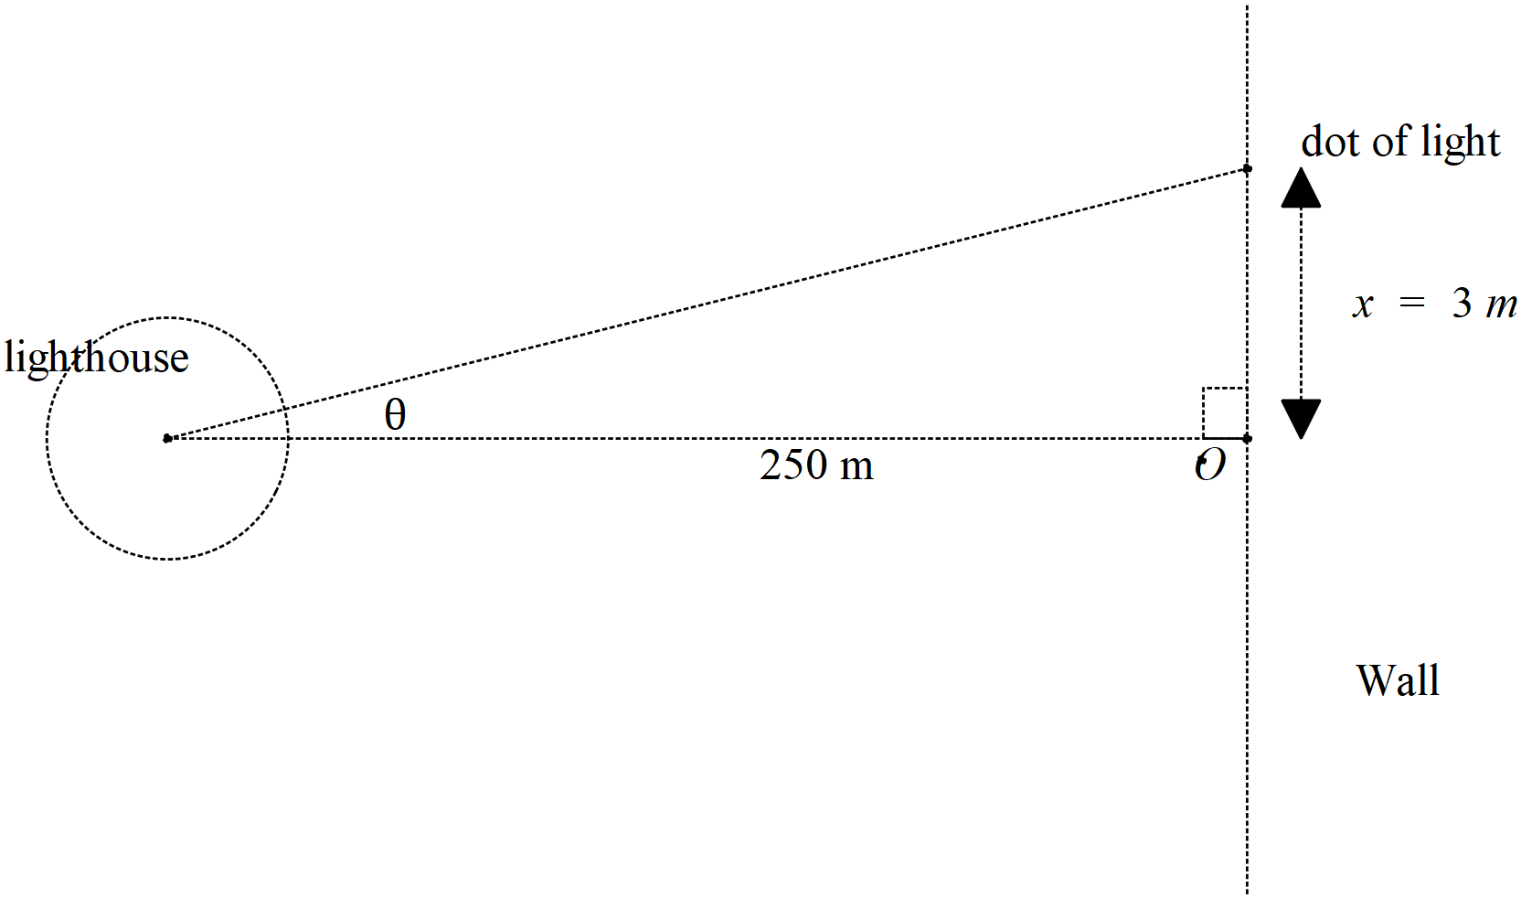
- Determine the speed of the dot of light on the wall when the dot is 3 metres away from the closest point to the lighthouse, pt O, see diagram above. (4 marks)

- If the artificial island containing the lighthouse is moving towards the shore, pt O, at a speed of 5 metres per second, determine the speed of the dot when 3 metres away from pt O and the lighthouse being 170 metres from the shore, pt O. (3 marks)

Q4 (3 marks) (4.1.3)
Show using logarithmic differentiation how to differentiate .

Q5 ( 8 marks) (4.1.1, 4.1.4)
Show how to evaluate the following without any use of the classpad. Show all working.

- (4 marks)

Q5 cont-
- (4 marks)

Q6 (7 marks) (3.3.15)
Consider a projectile that leaves with speed at an angle to the horizontal, see diagram. Assume that the constant acceleration is .
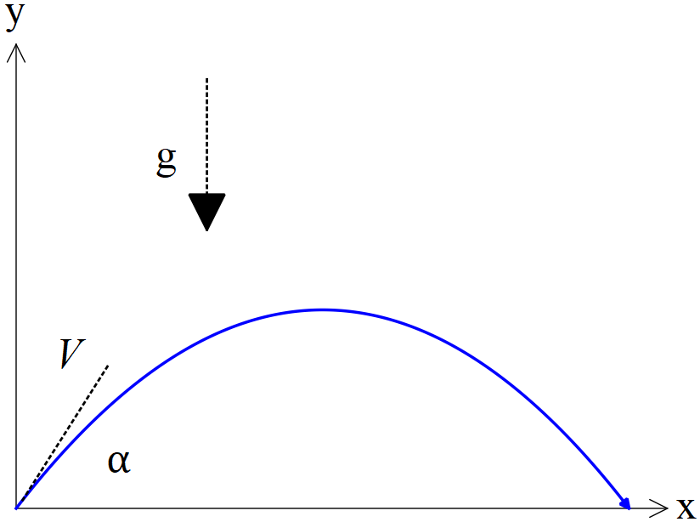

- Using vector calculus and starting with the acceleration, show how to derive the cartesian equation of the path in terms of . (4 marks)

- Given that and that when , determine possible value(s) for .
(3 marks)

Q7 (4 marks) (4.1.6)
Consider the area between , and the x axis with , as shown below.
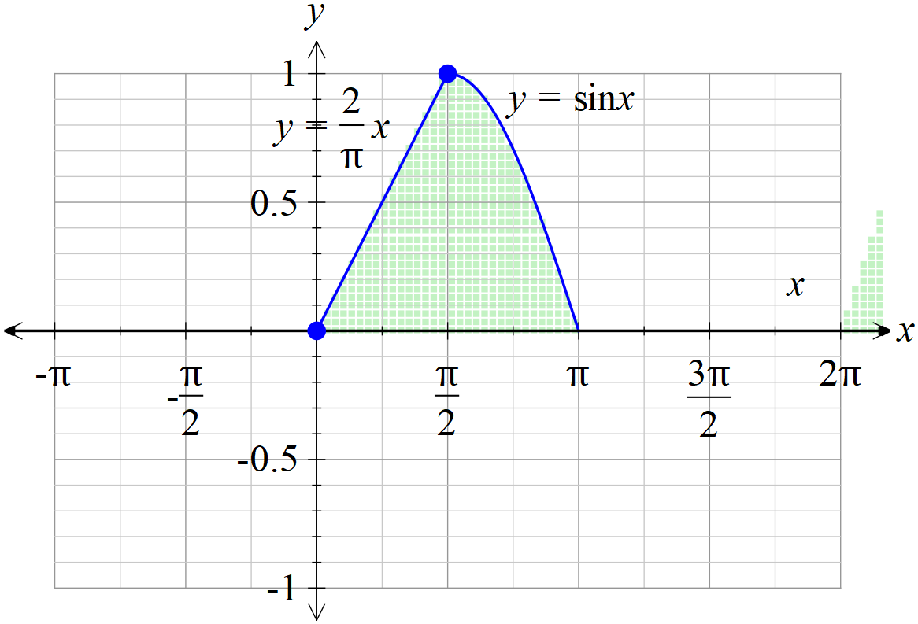

If the shaded area above is revolved around the y axis, determine the volume of the 3D object created to two decimal places.

